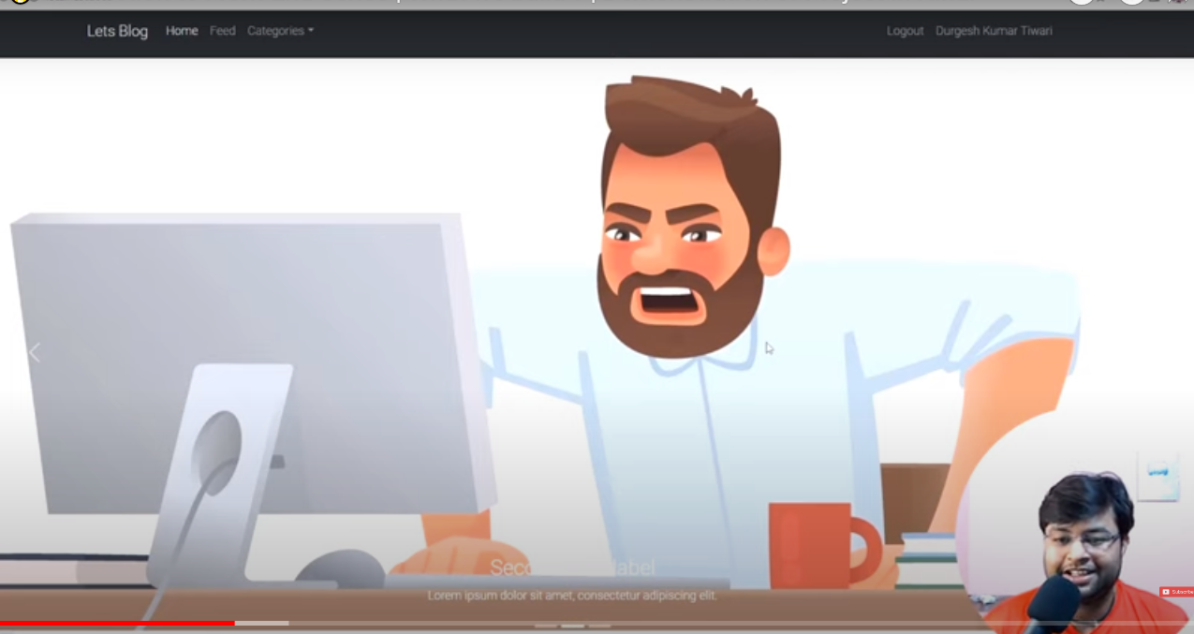

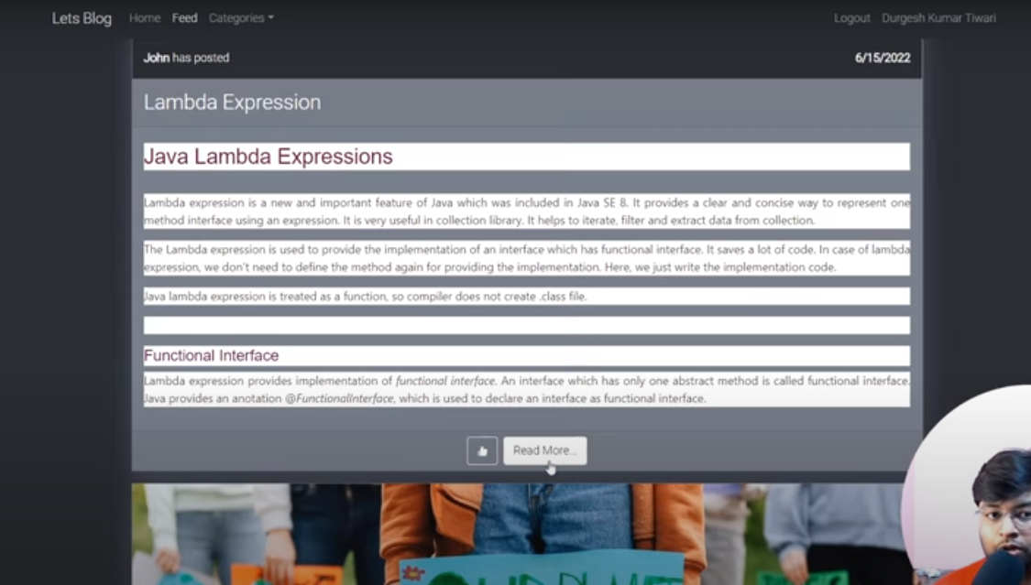

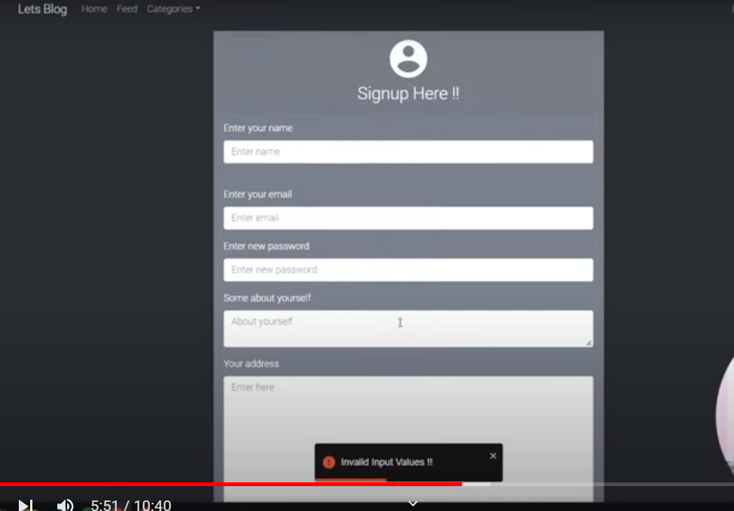

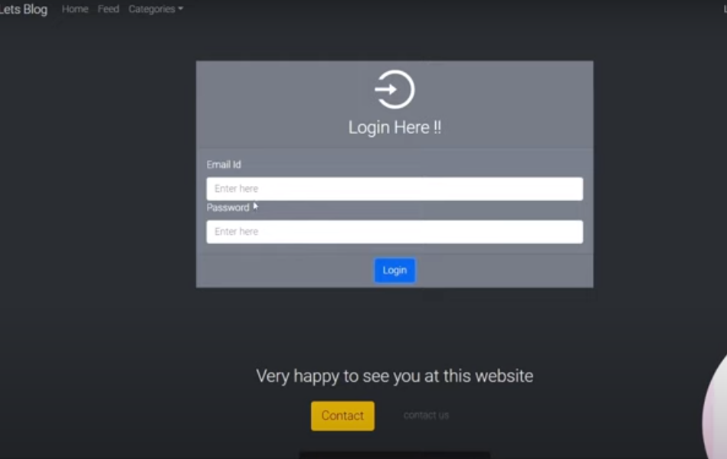

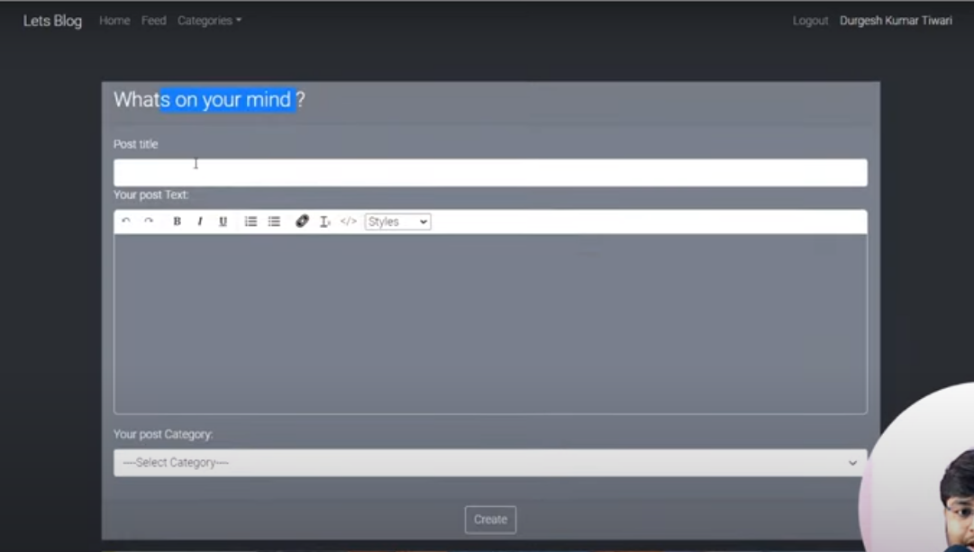

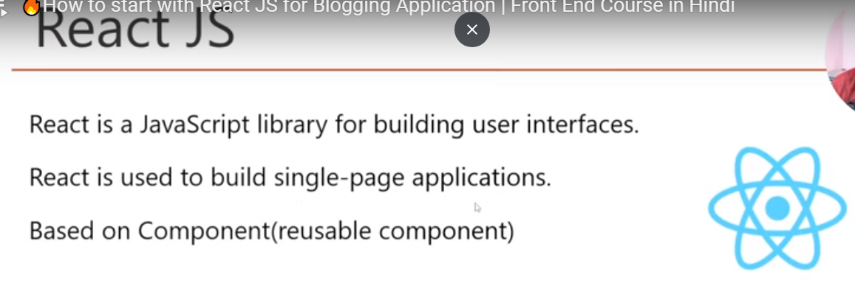

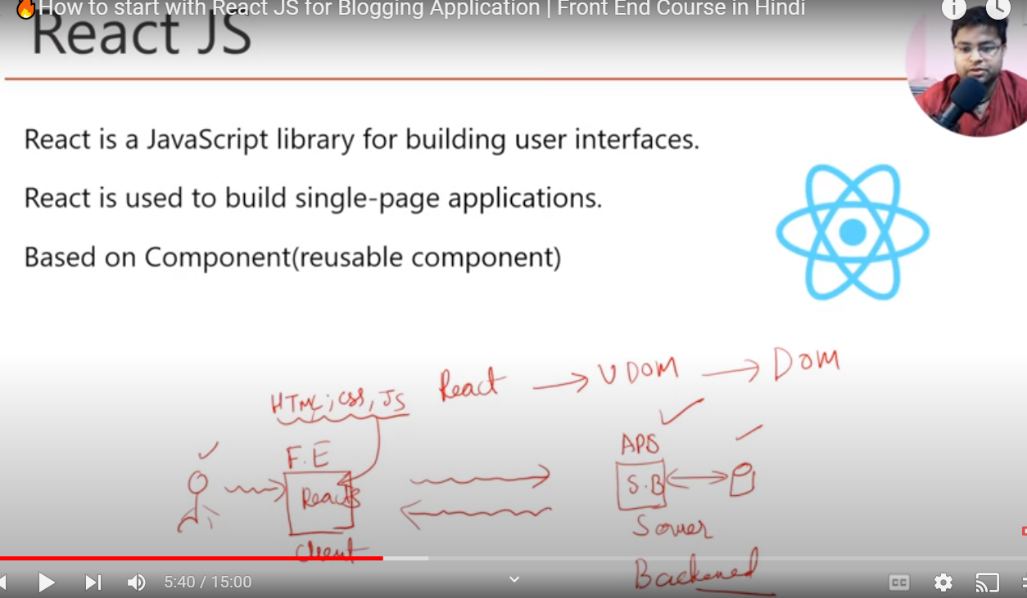

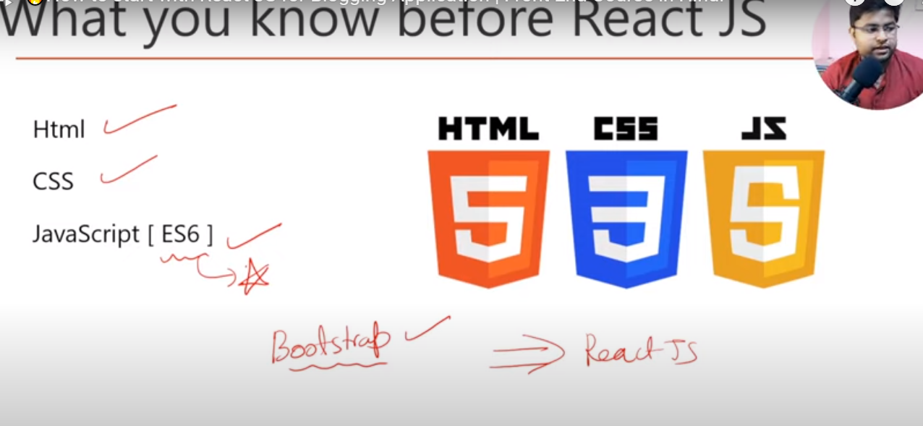

1. Install node js ([Node.js (nodejs.org)](https://nodejs.org/en/)

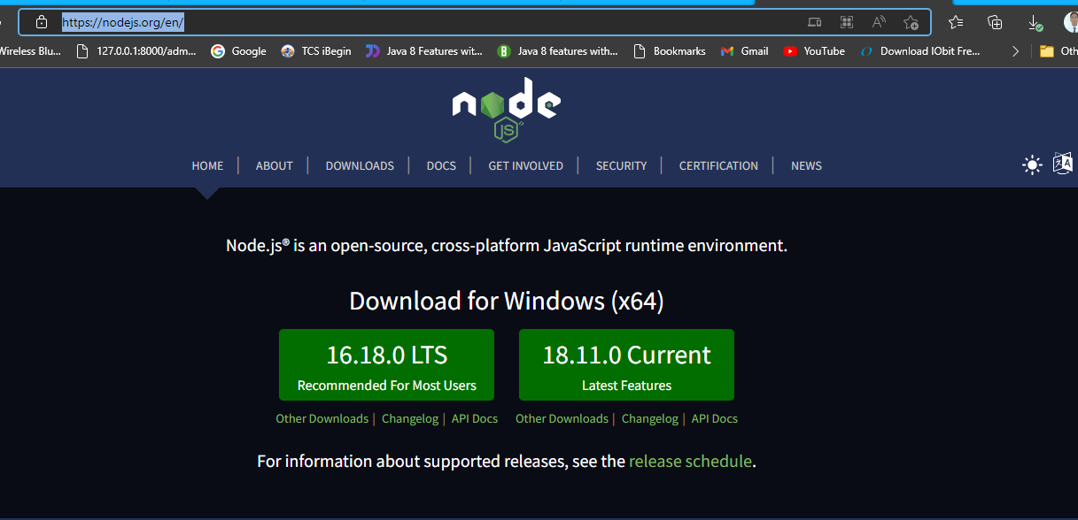

Click in 16.18.0 LTS and download and install

1. Check version 🡪 node -v

2. Package version🡪 npm -v

[Getting Started – React (reactjs.org)](https://reactjs.org/docs/getting-started.html)

Create new app

npx create-react-app blog-app

cd blog-app

npm start

Reactstrap

npm install reactstrap

npm install bootstrap

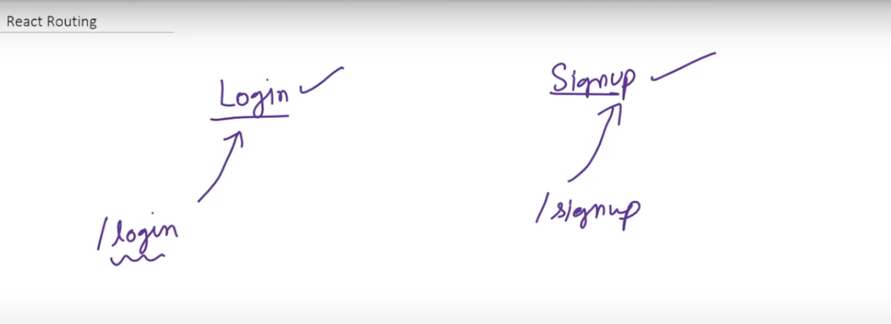

[Overview v6.3.0 | React Router](https://reactrouter.com/en/v6.3.0/getting-started/overview)

npm install react-router-dom@6

[reactjs - JSX or HTML autocompletion in Visual Studio Code - Stack Overflow](https://stackoverflow.com/questions/39320393/jsx-or-html-autocompletion-in-visual-studio-code)

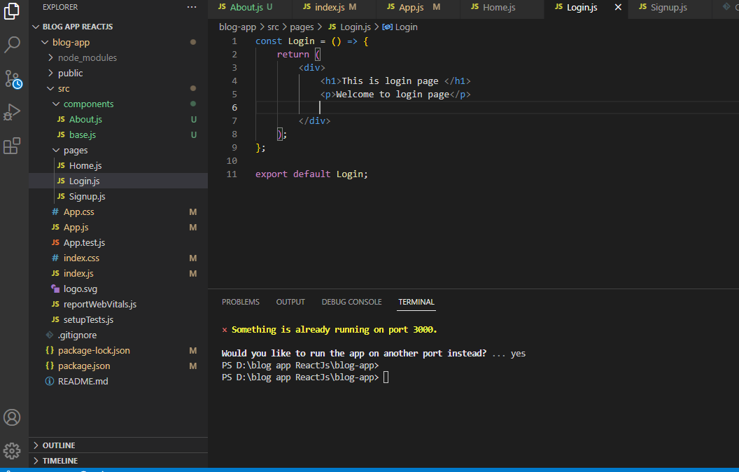

Click on left bottom corner setting icon and gain click on inside setting

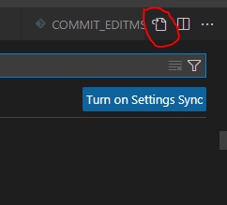

"emmet.triggerExpansionOnTab": true,

"emmet.includeLanguages": {

"javascript": "javascriptreact"

}